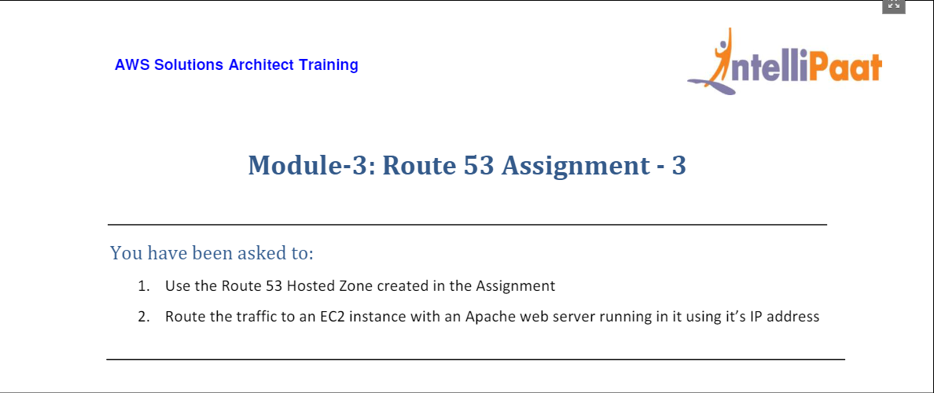

* Created hosted zone mayureshtungare.xyz and routed traffic to original webserver (from previous assignment to EC2 instance with IP 3.94.110.22.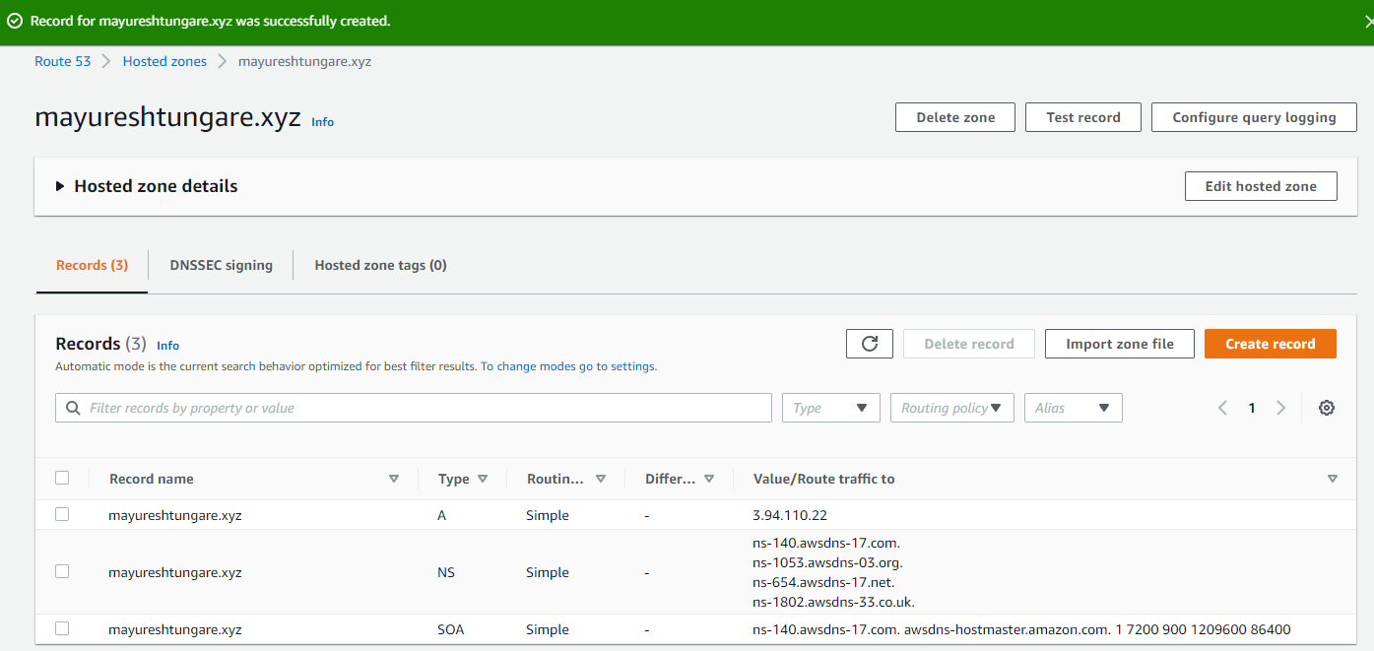

Screenshot of the original EC2 instance